Organized by  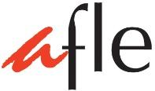 | 10th Hong Kong  French Speech Competition 2020

Prose Reading Passage Form (non-francophone participants only)

Notes
- Please send by email in .doc, .docx or .pdf (no pages or other picture format) on or before 20th November 2020 – 11:59 p.m.
- Use a different application form for each candidate

Gender
◻ Boys | ◻ Girls

Level

◻ P3 | ◻ P4 | ◻ P5 | ◻ P6
◻ S1 | ◻ S2 | ◻ S3 | ◻ S4 | ◻ S5

Candidate's name (exactly same as HKID card):

Competition passage:

Author | Title of the book |  | Publishing house
Selected passage (page number) | Number of the first line | Number of the last line | Total number of words

School name:
Teacher in charge:
AFLE Teacher Membership No:

Signature of Teacher-in-charge:

