Organized by  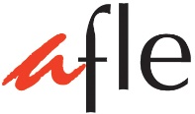 | 7th Hong Kong  French Speech Competition

Categories and Events
and Fees 2016

For Non-Francophone Candidates
 | Solo Poetry Speaking Boys (non-francophone) | Solo Poetry Speaking Girls (non-francophone) | Solo Prose Reading Boys (non-francophone) | Solo Prose Reading Girls (non-francophone)
P.3
P.4
P.5
P.6
S.1
S.2
S.3
S.4
S.5

For Francophone Candidates
Solo Poetry Speaking Boys and Girls
(francophone)
P.3-P.4
P.5-P.6
S.1-S.2

Fees
Solo Entry
(Solo Poetry Speaking
and/or Solo Prose Reading)
Primary | HK$70
Secondary | HK$90

