Organized by |  | Sponsored by
 |  |  | 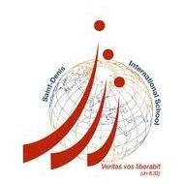

Les Césars de la Francophonie 2016
Video competition
« En allant à l’école... »

Registration form
(to return by email to info@aflehk.org on or before 5 Feb. 2016)

A. Personal particulars
Name: | Gender: M / F
HKID Card No: | Student No:
School: | Year of Study:
Date of Birth: | Mobile No:
Email address:
B. Teacher’s particulars:
French Teacher’s name:
AFLE membership No:
Email address:

The title of my video clip is:

___________________________________________________________

Reminder:
Last day to send the video clip together with the declaration form: 20 Feb. 2016.

